## horizontal line

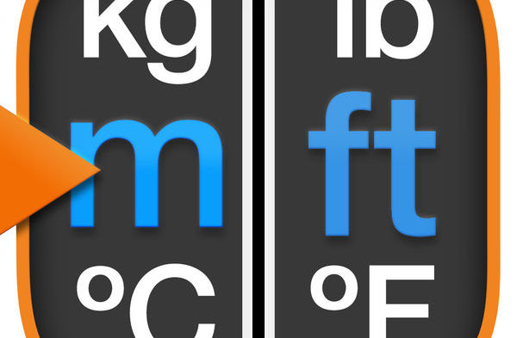­

Unit Conversion

13.05.2019

**─**

Group Members

Muhammad Qasim

Muhammad Kashif

Muhammad Mohsin

# Overview

The project is completely based on the conversion of units is the conversion between different units of measurement for the same quantity, typically through miltiplicative conversion factors. A conversion factor is used to change the units of a measured quantity without changing its value.

# Description

The project comprises of different multi-various options of conversion such as length, temperature, weight, volume and area. At the time of execution the program is going to ask user to enter above choice as an input. Let the user to enter the option. The program is going to provide much more features to calculate specific conversion in a single entity of all above option.

Conversion of unit is done according to the international standard of measurements. The pre-defined unit conversion tables and algorithms are available that make the conversion easy and convenient.

# Features

The project contains almost 30 functions to calculate specific conversion of all the given options. Such as conversion of millimeter to meter, celsius to fahrenheit, gram to kilogram, metersquare to centimetersquare, cubicfeet to cubicmeter and many more. The concepts of MIPS that has been used in this project are as follows

## Branches

## Conditions

## Floating point

## Functions